**PROPOSAL FOR**

**HOTEL MANAGEMENT SYSTEM DATABASE DESIGN FOR**

**DREAMLAND MANOR**

TSM/RPT/v0.1

BY

TSM CONSULTING FIRM

ASSIGNMENT: Development Team Project: Project Report

TEAM 3

Tasweem Beelunkhan, Shaun Bell-Gibson, Abiodun Maborukoje

MAY 2023

**TABLE OF CONTENT**

1. EXECUTIVE SUMMARY 1

2. INTRODUCTION 1

3. REQUIREMENT GATHERING 1

4. LOGICAL DESIGN 2

4.1. ER Model Diagram 2

4.2. Definition of Entities and Attributes 3

5. DATA MANAGEMENT PIPELINE 6

6. PROPOSED DBMS 7

7. CONCLUSION 7

8. REFERENCES 8

9. APPENDIX 9

9.1. Crow’s Foot Notation 9

**TABLES**

Table: 4.2-1 Entities and Attributes Definition……………………………………………..…………………………3

**FIGURES**

Figure 4.1-1 Dreamland Manor HMS ER Diagram……………………….……………………………………………2

Figure: 4.2-1 Relationship Definition………………………………………………………..………………………...4

Figure: 4.2-2 Data Types Definition…………………………………………………………………………...……….5

# EXECUTIVE SUMMARY

This design report presents the proposed database design for the Hotel Management System (HMS) of Dreamland Manor. The design aims to fulfil the requirements of the organization by providing an efficient system for managing hotel operations.

# INTRODUCTION

A Hotel Management System (HMS) allows for various management operations including room allocation, payments and information relating to the guests' needs (Hsu & Hsu, 2011). The purpose of an HMS is to enhance operational efficiency and optimize the performance of the hospitality establishment by enabling a centralised platform to streamline processes (Kasavana & Cahill, 2014). TSM Consulting’s role is to evaluate the needs of Dreamland Manor and create an HMS that is tailored to best suit these requirements.

# REQUIREMENT GATHERING

The scope of the system is to cover reservations, guest information, room assignments, and billing. Efficiently managed by the system to satisfy hotel management requirements.

In order to better understand and document the needs and expectations of all stakeholders, two methods of data collection are carried out:

1. Observational Method; The hotel's activities are closely observed in order to outline the discrepancies and liabilities found in the current manual system.
2. Interview Method; Interviews were carried out in a conducive environment to understand their feelings in order to come up with an effective system that will cater for their needs and their comfortability on the introduction of a new computerized system.

Functional requirements:

* Efficient management of room reservations, including the ability to check room availability, book rooms, and handle reservation modifications or cancellations.
* The system should support billing functionality, including the ability to generate invoices and manage transactions associated with hotel services.

Non-functional requirements

* Exhibit high-performance capabilities
* Ensuring quick response times in handling user requests.
* Secure authentication, and access controls.

# LOGICAL DESIGN

The proposed logical design for the HMS incorporates the following key features

* Data format is Structured (data will be organized with Table rows and columns)
* Database is in Third Normal Form (3NF)

## ER Model Diagram

The entity relationship diagram is a graphical representation of a problem domain being modelled (Song & Froehlich, 1995). The ER diagram provides a clear understanding of the various entities involved. Also, it identifies the attributes associated with each entity and establishes the relationships between them. The Crow’s Foot Notation (CFN) was used to design the diagram. The CFN’s use of symbols increases the speed and ease of interpretation when compared to character-using notions such as Chen or Weaver ( Schmieder et al., 2009).

*Figure 4.1-1 Dreamland Manor HMS ER Diagram*

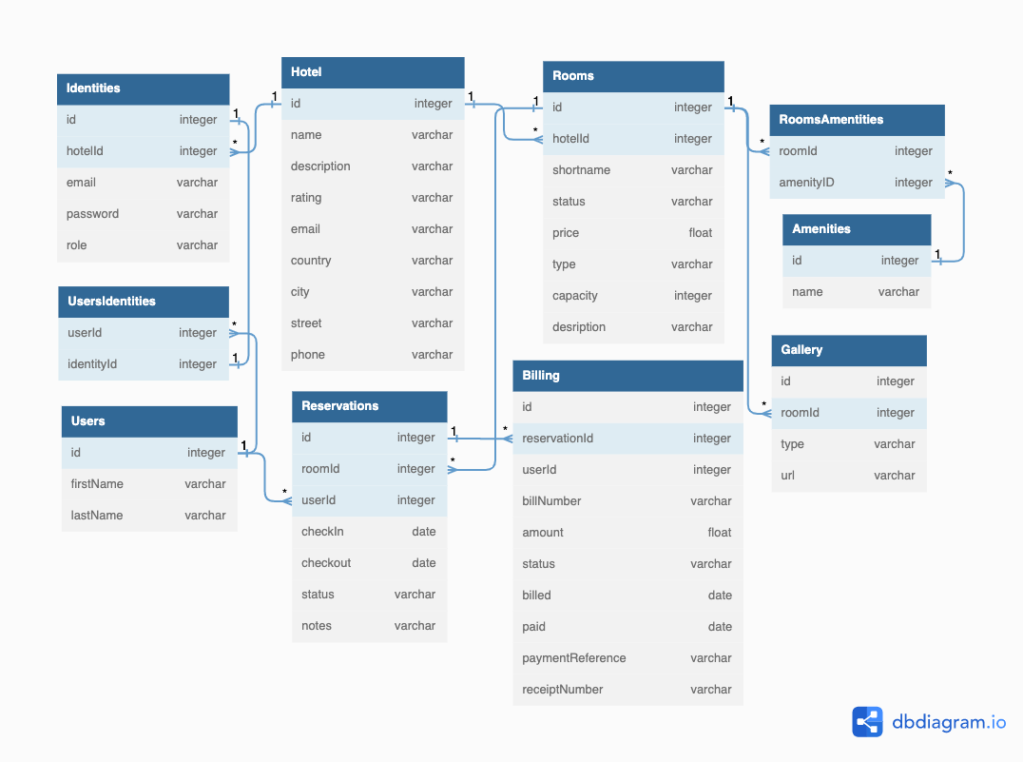

## Definition of Entities and Attributes

*Table: 4.2-1 Entities and Attributes Definition*

| **Entity** | **Description and Attributes** *(PK = Primary Key, FK = Foreign Key)* |
| --- | --- |
| Hotel | Represents the main information about the hotel itself.   * **id**: PK * **name**: The name of the hotel * **description**: A brief description of the hotel * **rating**: The quality level * **Country, city, street, email and phone**: The contact address of the hotel |
| Identities | Represents the individual account information needed to access the HMS.   * **id**: PK * **hotelId**: FK to Hotel * **email & password**: Account details for login * **role**: Authorisation roles can be (Admin, Staff or Guest) |
| Users | Represents individuals who interact with the HMS.   * **id**: PK * **firstname & lastname:** Name of each registered users or actors |
| Rooms | Represent the individual rooms or accommodations available at the hotel.   * **id**: PK * **hotelId**: FK to Hotel * **shortname**: Short name or code given to each room * **status**: Current status of a room if its being used or vacant * **price**: An amount a guest needs to pay for a room * **type**: Other details * **capacity**: Number of guest that can stay in the room * **description**: A description of the room |
| Gallery | Represents a collection of images or multimedia associated with each hotel room.   * **id**: PK * **roomId**: FK to Room * **type**: Media type of gallery item * **url**: An address to locate media item |
| Amenities | Represents the facilities, services, or features available at the hotel.   * **id**: PK * **name**: Name of amenity |
| Reservations | Represents the bookings or reservations made by guests.   * **id**: PK * **roomId**: FK to Room * **userId**: FK to User * **checkIn, checkOut**: Check in, out date * **status**: Reservation status,(Pending, Active or Canceled) * **note**: Other information |
| Billing | Represents the financial transactions associated with guest reservations and services provided.   * **id**: PK * **reservationId**: FK to Reservation * **userId**: FK to User * **billNumber**: Invoice number for the bill * **amount**: Amount to pay for the bill * **status**: Bill and payment status * **billed**: Billing date * **paid**: Payment date * **paymentReference**: Payment Reference * **receiptNumber**: Customer receipt number |

The figure below highlights the relationship between entities.

*Figure: 4.2-1 Relationship Definition*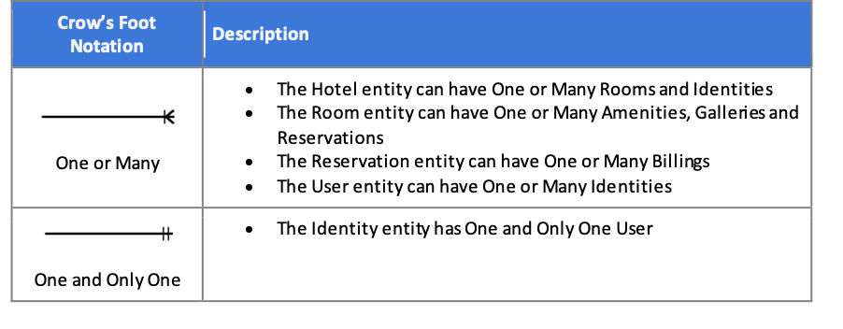

The Definition of Data Types

*Figure: 4.2-2 Data Types Definition*

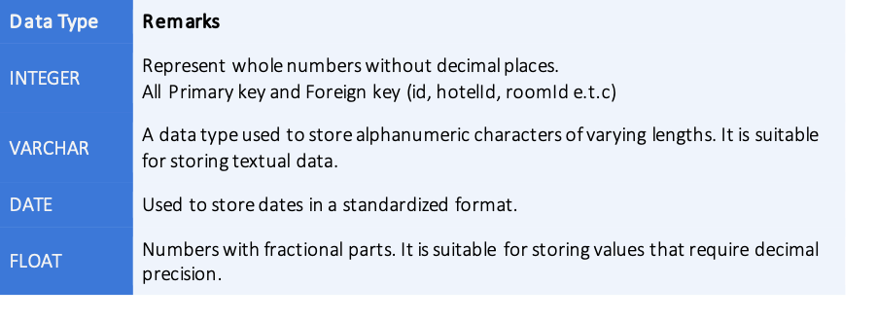

# DATA MANAGEMENT PIPELINE

| **Capturing Raw Data**  Raw data for the hotel management system was gathered from a variety of sources, including the company profile, guest information forms, legacy reservation and billing systems. The data was collected and saved in its original form for later processing. | **Data Cleaning**  During the data cleaning step, mistakes, inconsistencies, duplicate entries, missing values, and data formatting errors in the raw data were identified and corrected. Using python packages such as numpy and pandas. | **Data Integration**  The cleansed data from diverse sources was integrated and aggregated into a consistent format while keeping the database's conceptual design in mind. Mapping and aligning data fields, standardizing data formats, and verifying data consistency were all part of this procedure. |
| --- | --- | --- |
|  |  |  |
| **Database Design**  Based on the requirement gathered a database was created to store the integrated data. This includes designing tables, defining relationships between tables, and establishing data constraints. The database design ensures efficient storage, retrieval, and management of the data. | **Data Analysis**  The data was imported into the database and analyzed to obtain valuable insights. This step includes statistical analysis in order to find useful information for decision-making. | **Data Presentation**  The insights gained through data analysis will be presented in a comprehensible and visually appealing manner. This process entails developing visualizations, and reports to effectively communicate the findings to Dreamland Manor's managers. |

# PROPOSED DBMS

Based on the requirements of Dreamland Manor, a relational database management system (RDBMS) such as MySQL would be a good choice. MySQL is a popular open-source RDBMS that provides various benefits that align with the requirements:

* Data Integrity and Consistency
* Scalable
* High Performance
* Robust Security
* Broad Compatibility and Large Ecosystem
* Cost-effectiveness (Open Source)

There are other RDBMSs available that offer more functionality. However, overall MySQL provides the greatest array of benefits while balancing cost effectiveness with functionality (Denton & Peace, 2003).

# CONCLUSION

In conclusion, the proposed DBMS provides the necessary features and capabilities to meet Dreamland Manor's Hotel Management System requirements. It provides dependable data management, scalability, security, and cost-effectiveness, allowing for smooth operations and better decision-making.

# REFERENCES

Denton, J.W. & Peace, A.G. (2003) “Selection and Use of MySQL in a Database Management Course”, Journal of Information Systems Education (JISE), 14(4), pp. 401–408.

Hsu, L. C., & Hsu, C. W. (2011). A Study on the Application of a Hotel Management System Based on Cloud Computing. In 2011 International Conference on Electric Information and Control Engineering (ICEICE) (pp. 1987-1990). IEEE.

Kasavana, M. L., & Cahill, D. L. (2014). Technology Strategies for the Hospitality Industry (2nd ed.). Pearson.

I. Puja, P. Poscic and D. Jaksic (2019). "Overview and Comparison of Several Relational Database Modelling Methodologies and Notations," 2019 42nd International Convention on Information and Communication Technology, Electronics and Microelectronics (MIPRO), Opatija, Croatia, 2019, pp. 1641-1646, doi: 10.23919/MIPRO.2019.8756667.

Schmieder, P., Plimmer, B. and Dobbie , G. (2009) ‘Sketching ER diagrams ’, *Department of Computer Science University of Auckland* [Preprint].

Song Il-Yeol & Froehlich K. (1995) "Entity-relationship modeling," in IEEE Potentials, vol. 13, no. 5, pp. 29-34, Dec. 1994-Jan. 1995, doi: 10.1109/45.464652.

# APPENDIX

## Crow’s Foot Notation

| **Item** | **Description** |
| --- | --- |
|  | Zero |
|  | One |
|  | Many |
|  | Zero or Many |
|  | One or Many |
|  | One and Only One |
|  | Entity |